COAL LAB MID-TERM

**Question 6:**

Write a MIPS Assembly program that inputs an integer value. The program should output **Prime**if the number is prime. Otherwise, it should output **not Prime**.   .

* Please paste the screen shot of Code and output on doc file labeled with your Rollno and Upload it.

**CODE:**

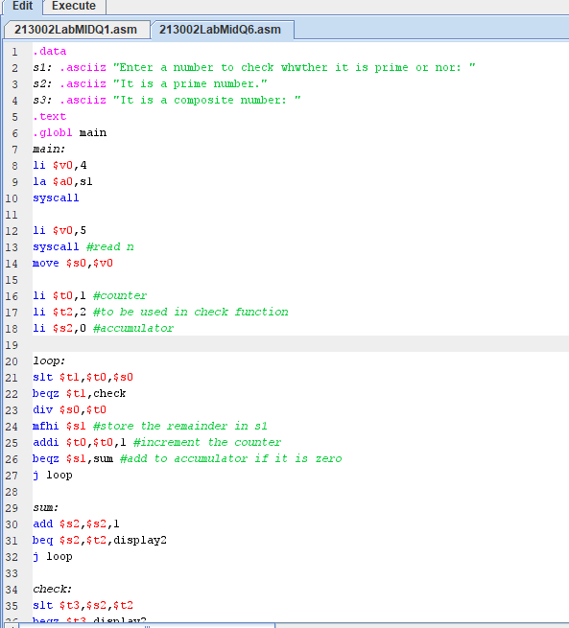

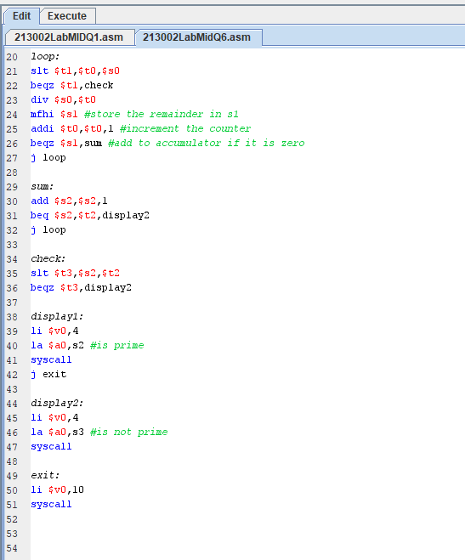

**Output:**

